

**Event Planning Guide**

The purpose of document is to provide a comprehensive overview of event options at the university and in the community; outline the event-planning process within the faculty; and, provide framework for cost management and approval.

Last updated August 15, 2017.

Contents

Introduction- Event Planning at FHSD 3

Goal and Objectives 3

Stakeholder Mapping 3

Venue Overview 4

Campus Venue Options 5

Ballroom 6

EME Mezzanine 7

EME Foyer 7

Fipke Foyer & Mezzanine 7

Arts Atrium 8

Foyers 8

Sunroom 9

Faculty & Staff Lounge 9

University Theatre 9

Innovative Learning Centre 10

Community Venue Options 10

Mary Irwin Theatre 10

Laurel Packing House 11

Sandhill Event Space 11

Kelowna Community Theatre 12

Delta Grand Okanagan 12

Kelowna Co+Lab 13

Innovation Centre Theatre 13

FHSD Event Planning Processes 14

High-Level Events vs. Standard Events 14

# Introduction- Event Planning at FHSD

The goal of events for FHSD is to increase engagement by building community, morale, and commitment, fostering an understanding of the faculty’s aspirations and building support for its continued success. This document will evolve and should be considered a working document.

This planning guide does the following:

* Provides a comprehensive audit of event venues for event planners within FHSD
* Delivers recommended event planning schedule and outline
* Outlines required steps and approval policy regarding events within FHSD

# Goal and Objectives

School of Nursing

The goal for FHSD’s event planning is to ensure all events within the faculty follow a consistent planning schedule to ensure maximum reach to our valued stakeholders.

# Stakeholder Mapping

|  |
| --- |
| **Group** |
| **FHSD Leadership**  Dean, Associate Dean, School Directors, and School Associate Directors |
| **Faculty and Staff (internal)**   * **School of Nursing**   Faculty  Staff  Clinical Assistants  *important to note many stakeholders are not full-time on-campus and access information remotely and have shared roles with UBC/Interior Health.   * **School of Social Work**   Faculty  Staff   * **School of Health and Exercise Sciences**   Faculty  Staff  Lab technicians/support roles   * **Dean’s Office**   Staff |
| **Students**   * Prospective Students * Current Students   Undergraduates  Postgraduates  Research assistants  International Students  Distance learning (MSN) |
| **External Advisory Committee** |
| **Community Partners**   * Practicum Placements * Field Education Coordinators * Community Engagement Partnerships |
| Development |
| Alumni |

# Venue Overview

|  |  |  |  |  |
| --- | --- | --- | --- | --- |
|  | Capacity | Cost | Contact |  |
| Mary Irwin Theatre (RCA) | 326 | $515-$940  *request non-profit rate  ** UBC has a standing agreement for limited community use of theatre. Please see full venue details for how to request a UBC booking | rentals@ rotarycentreforthearts.com  Ph: 250-717-5304 ext 111 | Community |
| Laurel Packing House | 300 standing  200 seated | $500-2,200  *40% discount for specifically designated not-for profits.  (UBC student associated events can qualify. Administrative organized events may not. Inquire on case-by-case basis) | Ph: 778.478.0325  Email: [bookings@kelownamuseums.ca](mailto:bookings@kelownamuseums.ca)  *availability calendar available online at http://laurelpackinghouse.ca/ |
| Sandhill Winery | 210 standing  70 seated | $275/hour  Maximum charge $1650 | Ph: 250-979-4211  Customer Inquiries: requestinfo@sandhillwines.ca |
| Kelowna Community Theatre | 853 | $800 per day or $1200 when selling tickets for a touring production  *request non-profit rate | Ph: 250-469-8944  *contact Suann Brown [suann.brown@ubc.ca](mailto:suann.brown@ubc.ca) if you would like to investigate the UBC partnership |
| Delta Grand Okanagan | 10-1100 | $4,000 Full conference space per day  $2,000 audio rental | Visit  <http://www.marriott.com/hotels/event-planning/business-meeting/ylwok-delta-hotels-grand-okanagan-resort/> |
| Co+Lab | 50 | $ 100 per hour  $525 per day  $895 weekend booking | hello@okcolab.com  Phone: 778-821-1932 (Shane) |
| Innovation Centre Theatre | 100 | $85 per hour  $270 per half day  $475 per day | Contact Brea Retzlaff  Operations Manager  brea@accelerateokanagan.com |
| Ballroom | 200 | $200 /hour | Book through UBC Okanagan Bookings  <http://cbo.ok.ubc.ca/booknow.html> | On-Campus |
| Campus Foyers | 50-100 | No cost |
| Arts Atrium | 150 standing  40 seated |
| Sunroom | 300 |
| Faculty and Staff Lounge | 30 |
| Innovative Learning Centre | 50 standing  25 seated |
| University Theatre | 200 |

# Campus Venue Options

To book please visit UBC Okanagan’s booking site at:

<http://cbo.ok.ubc.ca/booknow.html>

|  |  |
| --- | --- |
| Audiovisual | Audiovisual support is kindly offered by UBC IT, Media and Classroom Services. In many cases there will be a screen in the room, but where there isn’t please reach out to book supporting audio/visual requirements by placing a work ticket with IT’s Helpdesk: <https://helpdesk.ok.ubc.ca/ihelp/?system=av_equipment>  *Novell Login required |
| Catering | Catering can be ordered through:  **Aramark**  <https://ubco.catertrax.com/> * Aramark is UBC Okanagan’s food services partner. Aramark will deliver all the items for the catering and clean up.  External Options *\*These options need to be picked up but can offer more economical options for catering if required.*  Green Thread Café (UBC Okanagan Campus) Phone: (250) 807-8078   Nesters Market (party trays) Phone: (250) 491-0642 |
| Parking | All events at UBC are subject to Parking rules and regulations. In special cases, you can request a parking code to pay directly for your guest’s parking charges. You can contact parking at [okanagan.parking@ubc.ca](mailto:okanagan.parking@ubc.ca) or 250-807-8554. Request a ‘parking coupon’ which will provide you with a code to give your visiting guest. Parking will then invoice you and you can pay on you school’s behalf. |
| Room Set-Up | If your event is taking place in a room that is not already set-up to host your event (for example a reception in the foyer) you need to place a work request to UBC Okanagan Facilities Management. Visit this site to place a [Facilities Management Service Request](http://www.fis.infrastructuredevelopment.ubc.ca/archibus/schema/ab-core/views/process-navigator/navigator-details.axvw;jsessionid=F31D0650914C0D73BEFB9884496B4A80?username=ACGRANT&projectId=UBC_PROD) . Be sure to identify 'EVENT’ in Type of Problem. Specify what furniture and set-up is requested for your space. A very helpful tool is including a floor plan for your event. Examples of floor plans are found in the appendix of this document. |

## BallroomBallroom

Located on the second floor of the University Centre, the ballroom offers approximately 3,000 square feet of multipurpose space and a small outdoor patio. In addition to multipurpose space, this location is an impressive setting for elegant social events, receptions and lectures. The room is outfitted with state-of-the-art technology to compliment any event.  SOCAN and Re:Sound fees may apply to your event, please click [here](http://cbo.ok.ubc.ca/resources.html#SOCAN)for more information

For a banquet style event, the standard set up is 17 table rounds of eight people, to a capacity of 136.   We are privileged to have a grand piano in the ballroom. If you wish to use the piano, please contact Student Services at UNC 206Z or phone 250-807-9100. For set-up configurations, rates, **pl**ease read the [Ballroom Terms and Conditions](http://cbo.ok.ubc.ca/__shared/assets/UNc200_Terms37015.pdf).

|  |  |
| --- | --- |
| Audiovisual | Drop down screen and built-in sound system |

## EME MezzanineEME Mezzanine

EME Mezzanine is a space connecting the building's north and south towers.  There are some informal learning space and soft seating in this space.  It's a perfect venue for event registration, small trade-shows, and casual gatherings.

|  |  |
| --- | --- |
| Audiovisual | No audio visual. Must be requested. |

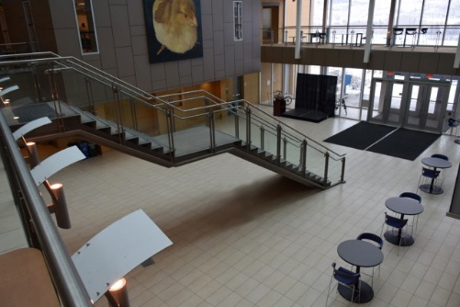

## EME Foyer

EME Foyer is located on the '0' level, just below the Mezzanine.  There are informal learning furniture on both sides of the space.  This foyer is suitable for cocktail reception, poster sessions, trade-shows, casual dining, casual gatherings, and coffee breaks.

**Note:** There can be a 6' x 6' stage in the space (pictured right)

|  |  |
| --- | --- |
| Audiovisual | No audio visual. Must be requested. |

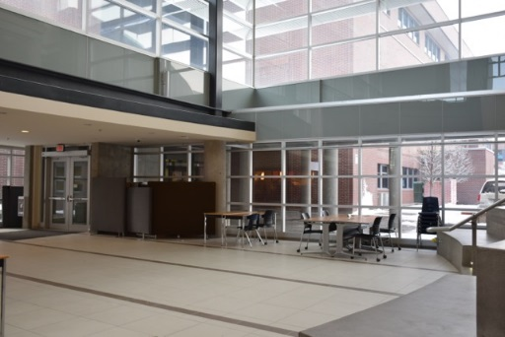Fipke Foyer & Mezzanine

The architecture of the Foyer and Mezzanine offer a unique atmosphere for any style of event. Combined space is 5,490 square feet, and individually the Foyer is 3,050 square feet and the Mezzanine, 2,440.  Please note that a good portion of the space has informal learning space furniture in it.

The Mezzanine is a great location for registration and poster sessions.  The Foyer is a space with casual soft seating that is ideal for casual gatherings, small trade-shows and poster sessions.

|  |  |
| --- | --- |
| Audiovisual | No audio visual. Must be requested. |

## Arts atriumArts Atrium

The Arts Atrium is a very unique, indoor green space full of plant life.  This space has been deemed a 'Quiet Zone' for students Monday to Friday.  This location is ideal for event registration, coffee breaks and cocktail receptions.

**Note:** The capacity is 40 seated and 150 standing; total space is 4050 square feet.  Bookings into this room will be considered for weekends only.

|  |  |
| --- | --- |
| Audiovisual | No audio visual. Must be requested. |

## Arts foyerFoyers

Foyers are great locations for coffee breaks, poster sessions and event registration. Six foyer options are available and located in the following buildings: Administration, Arts, Arts and Science, EME, Creative and Critical Studies, and Science.

|  |  |
| --- | --- |
| Audiovisual | No audio visual. Must be requested. |

## SunroomNewSunroom

This 4,000 square foot dining room with seating for up to 300 guests is an ideal location for a banquet. This space also has a small outdoor patio, perfect for casual gatherings.

**Note:** This space is available from May to August only.  This is designated student informal learning space throughout the rest of the year.

|  |  |
| --- | --- |
| Audiovisual | No audio visual. Must be requested. |

## Faculty LoungeFaculty & Staff Lounge

Great for informal meetings or small functions, this fresh space includes a combination of soft seating and tables and chairs that will accommodate approximately 30 people. The room is equipped with a TV and kitchen.

**Note:** This space is bookable after 4:00 pm only.  As this is dedicated to be a staff lounge, bookings for meetings can be held in the staff lounge after 4 pm but cannot be booked on a recurring basis.

|  |  |
| --- | --- |
| Audiovisual | No audio visual. Must be requested. |

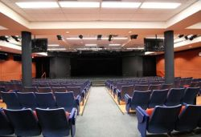University Theatre  
  
The University (also known as the ADM026 Lecture Theatre) Theatre is ideal for plenary sessions of up to 200 and is located in the Administration building. This beautifully appointed theatre features plush seats with flip top desks for the comfort and practical needs of guests. The touch top podium with DVD, VCR, LCD Projection, 20” screen and sound system enables control of all the audio visuals. The Theatre also has a full range of up-to-date theatre lighting and sound options in a recently renovated technical booth.  Skilled assistants are available to set and run the lighting and sound equipment.  This space can be booked as a meeting only or for a performance type of event

|  |  |
| --- | --- |
| Audiovisual | Drop down screens and built-in sound system. Important to test system prior to event. |

## Innovative Learning Centre

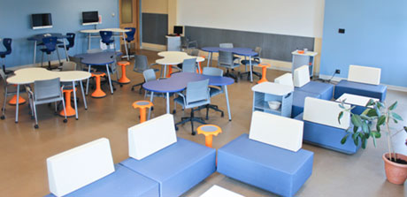http://innovativelearningcentre.ca

The Innovative Learning Centre is a unique location which can host around 50 and is located in the Engineering Management and Education Building. This space can be booked as a meeting only or for a lecture type of event. The unique campfire sitting arrangements offer flexibility in the space and allow for groups to break out into smaller groups for discussion.

|  |  |
| --- | --- |
| Audiovisual | Drop down screen and built-in sound system |

# Community Venue Options

## Mary Irwin Theatre

[rotarycentreforthearts.com/port/mary-irwin-theatre/](https://rotarycentreforthearts.com/port/mary-irwin-theatre/)

UBC has a partnership with Mary Irwin Theatre. The partnership provides approved UBC events with the opportunity to book at a lower cost. This partnership is facilitate through Community Engagement in University Relations.

|  |  |
| --- | --- |
| Capacity | 326 seats plus 6 wheelchair access seats |
| Audiovisual | All lighting and sound is provided in theatre. Event required to pay technician fee |
| Catering | Available through RCA’s Bistro |
| Parking | Limited parking. Available paid parking at library, Prospera etc. |

*Important to note: partnership rates are only offered with through official partner channels, and parking can be an issue so recommended to check events at Prospera to see if demand will be high.

## Laurel Packing House

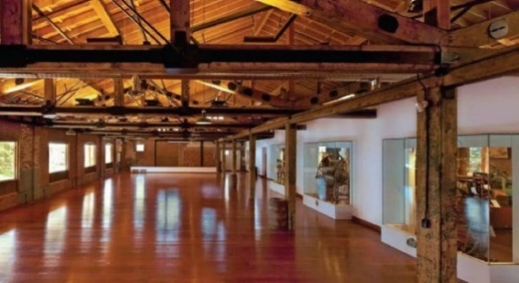[kelownamuseums.ca/museums/the-laurel-packinghouse/](https://www.kelownamuseums.ca/museums/the-laurel-packinghouse/)

|  |  |
| --- | --- |
| Capacity | 300 stand-up, 230 sitting down |
| Audiovisual | All lighting and sound must be brought into space |
| Catering | Available through RCA’s Bistro |
| Parking | Limited parking. Available paid parking at library, Prospera etc. |

*Important to note: partnership rates are only offered with through official partner channels, and parking can be an issue so recommended to check events at Prospera to see if demand will be high.

## Sandhill Event Space

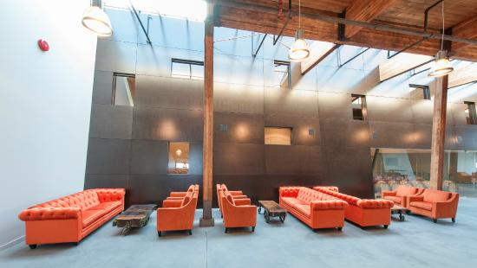[peller.com/cms/public/images/Image/2016/Sept/Sandhill-Event-Package-WEB.pdf](http://www.peller.com/cms/public/images/Image/2016/Sept/Sandhill-Event-Package-WEB.pdf)

|  |  |
| --- | --- |
| Capacity | 210 people |
| Audiovisual | All lighting and sound must be brought into space |
| Catering | External and would include rentals for all dishware (wine glasses provided by Sandhill) |
| Parking | Limited parking. Available paid parking at library, Prospera etc. |
| Cost | $275 per hour, maximum charge of $1650 |
|  |  |

## Kelowna Community Theatre

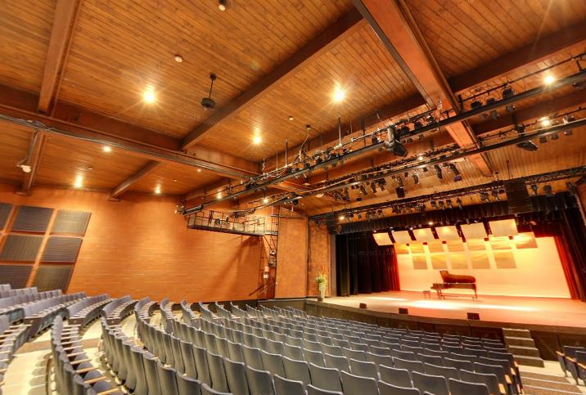[theatre.kelowna.ca/rental-information](https://theatre.kelowna.ca/rental-information)

|  |  |
| --- | --- |
| Capacity | 853 people |
| Audiovisual | All lighting and sound is provided in theatre. Rental includes 8 hours of technician time |
| Catering | External and would include rentals for all dishware |
| Parking | Limited parking. Available paid parking at library, Prospera etc. |
| Cost | $800 per day, |
|  |  |

*Important to note: partnership rates are only offered with through official partner channels, and parking can be an issue so recommended to check events at Prospera to see if demand will be high. Please contact UBC’s community engagement office to request partnership booking:

## Delta Grand Okanagan

|  |  |
| --- | --- |
| Capacity | Ballroom/Conference Max 1100 |
| Audiovisual | All lighting and sound must be sourced. Event required to pay technician fee, or patch fee |
| Catering | Provided by the Delta |
| Parking | Hotel parking available at an additional cost. Available paid parking at library, Prospera etc. |
| Cost | Space Rental $4,000 + Audio $2,000 + Catering |

## Kelowna Co+Lab

[okcolab.com/the-space/event-workshop-space/](http://okcolab.com/the-space/event-workshop-space/)

|  |  |
| --- | --- |
| Capacity | 50 |
| Audiovisual | Some lighting and sound is provided. |
| Catering | External and would include rentals for all dishware |
| Parking | Limited parking. Available paid parking at library, Prospera etc. |
| Cost | $100 per hour / $525 per day / $895 weekend booking |

## Innovation Centre Theatre

|  |  |
| --- | --- |
| Capacity | 100 |
| Audiovisual | All equipment provided, not technology support provided |
| Catering | External and would include rentals for all dishware (Perch restaurant available on roof of Innovation Centre) |
| Parking | Limited parking. Available paid parking at library, Prospera etc. |
| Cost | $85 per hour / $270 per half day / $475 per day |

## FHSD Event Planning Processes

##### High-Level Events vs. Standard Events

The process for sharing your event will depend on the level of event. There are two levels of event: High-level event and standard event. A high-level event is an event that is either a large community event (over 25 persons), an event with a budget associated with its execution. A standard event is an event that is run by a faculty or staff member where the planning takes place outside of the Dean’s Office. A standard event will be administrated by a school administrator.

## High-Level Event Process

**Step 1: Confirm your Event Project Sponsor by completing the FHSD Event Project Scope Form**

Every faculty event that requests the use of FHSD resources must have a project sponsor. The Sponsor is responsible for the budget assigned to the event. This person is usually a Director/Dean. While some events may originate from a Director/Dean, it is best practice to complete the form to capture the scope of support required.

Find the form at: <https://fhsd.ok.ubc.ca/event-planning/>

##### Step 2: Complete the Event Planning Checklist

While the checklist is not exhaustive, it can provide a good start to capturing the steps of hosting an event. An important part of this checklist to note is identifying your team members. Keep in mind that the request of time from the team is *generally* additional to a person’s regular responsibilities. Ensuring that all team members agree to the timeline and deliverables is an important step. Lastly, identifying one individual who is responsible for the coordination of the team and event logistics ensures that each of the tasks are accomplished.

Items to consider:

* If you are collaborating with a speaker or external organization have you clearly outlined how this partnership will take place?

It is recommended that an agreement is constructed to ensure that all parties are on the same page.

* Have you consulted with Marketing and Communications to determine the costs of the event promotion?
* There is considerable administration to hosting an event. It is important that all aspects are recognized

Find the form at: <https://fhsd.ok.ubc.ca/event-planning/>  
  
Standard Event Process  
Visit the <https://fhsd.ok.ubc.ca/event-planning/> to download event resources.

**Step 1: Create Event Promotion Materials**

1. Create a poster (vertical or horizontal)
2. Complete digital signage   
   *Submit to the Communications and Marketing Strategist*

**Step 2: Upload the Event to the FHSD Calendar**\* How-to available under event resources

**Step 3: Upload the Event to the UBC Events Calendar**